Fire Risk Assessment

1 Premises Details

Premises Name | Springhill Cohousing Community
Address | Springhill  Stroud  GL5 1TN
Contact Telephone Number
07958777249
Use of Premises | Residential
Name of Responsible Person/Owner/Employer/Person in Control of Workplace | David Michael
Single or more than one occupier in the premises | Single ◻ Multiple Occupiers √
If there is more than one occupier, have you discussed the fire safety arrangements for the building together? | Yes √ No ◻

Date assessment conducted | 9th Nov 2023
Name and details of person conducting assessment | David Michael
Review date for assessment | Nov 2025

2 Fire Safety Policy Statement

Statement:

‘It is the policy of Springhill Cohousing Community to protect all persons including residents, employees, visitors, contractors and members of the public from potential injury and damage to their health.

Signed: ……D Michael…… Date: 9th Nov 2023
(Print name) …David Michael……………………………………………

3 General Description Of The Premises

Give a general description of the premises and the use to which it is put.
Hours of the day and days of the week the premises is used.

Total number of persons present in the premises at any one time
Between 40 and 150, average around 70. About 90 residents.
Number of dwellings: 34 plus a work studio plus a Communal building (common house)
Size of the premises in square feet: 33,000 sq ft plus 3,000 sq ft common house
Number of floors
Houses: 2 ( some have 3 floors)
Flats: 4
Common House: 3

How many floors do you occupy?
All of them
Construction of building e.g. brick built, tiled pitch roof

Timber frame, Heraclif clad with timber and render over. Concrete tiled roof and PV panels and solar thermal.

4 Plan Drawing

A plan could be drawn and/or a description of the premises to show the layout of the building and the location of any general fire precautions and fire exits.

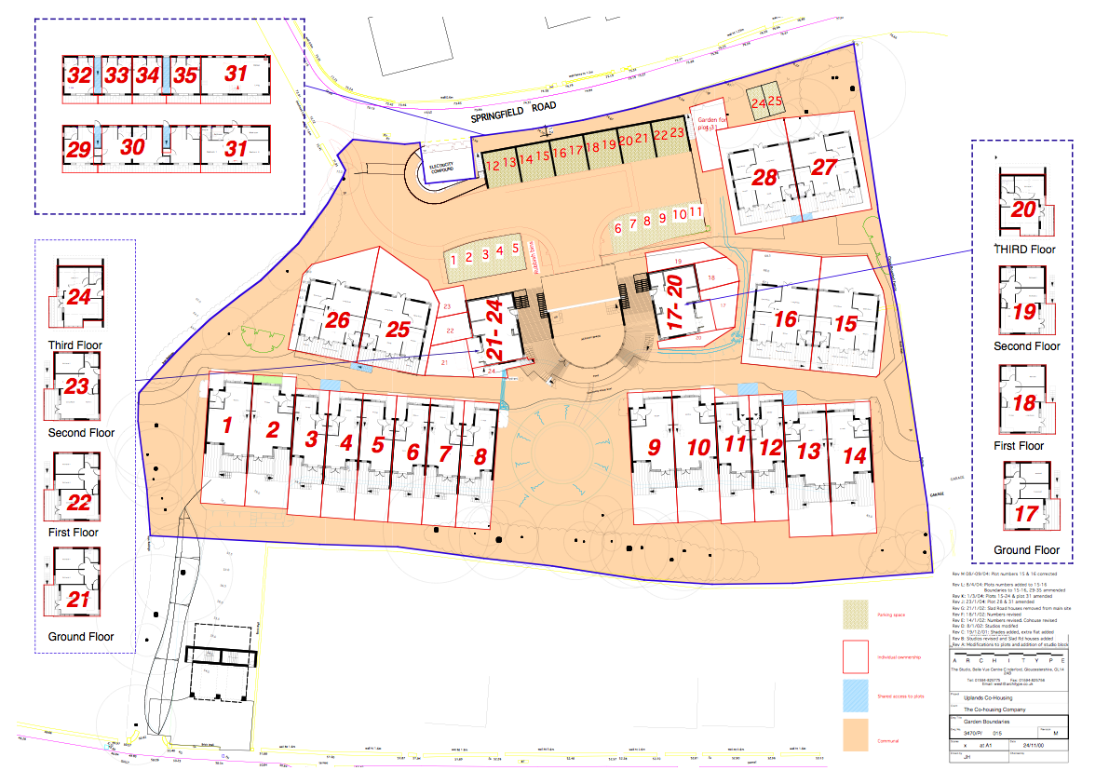
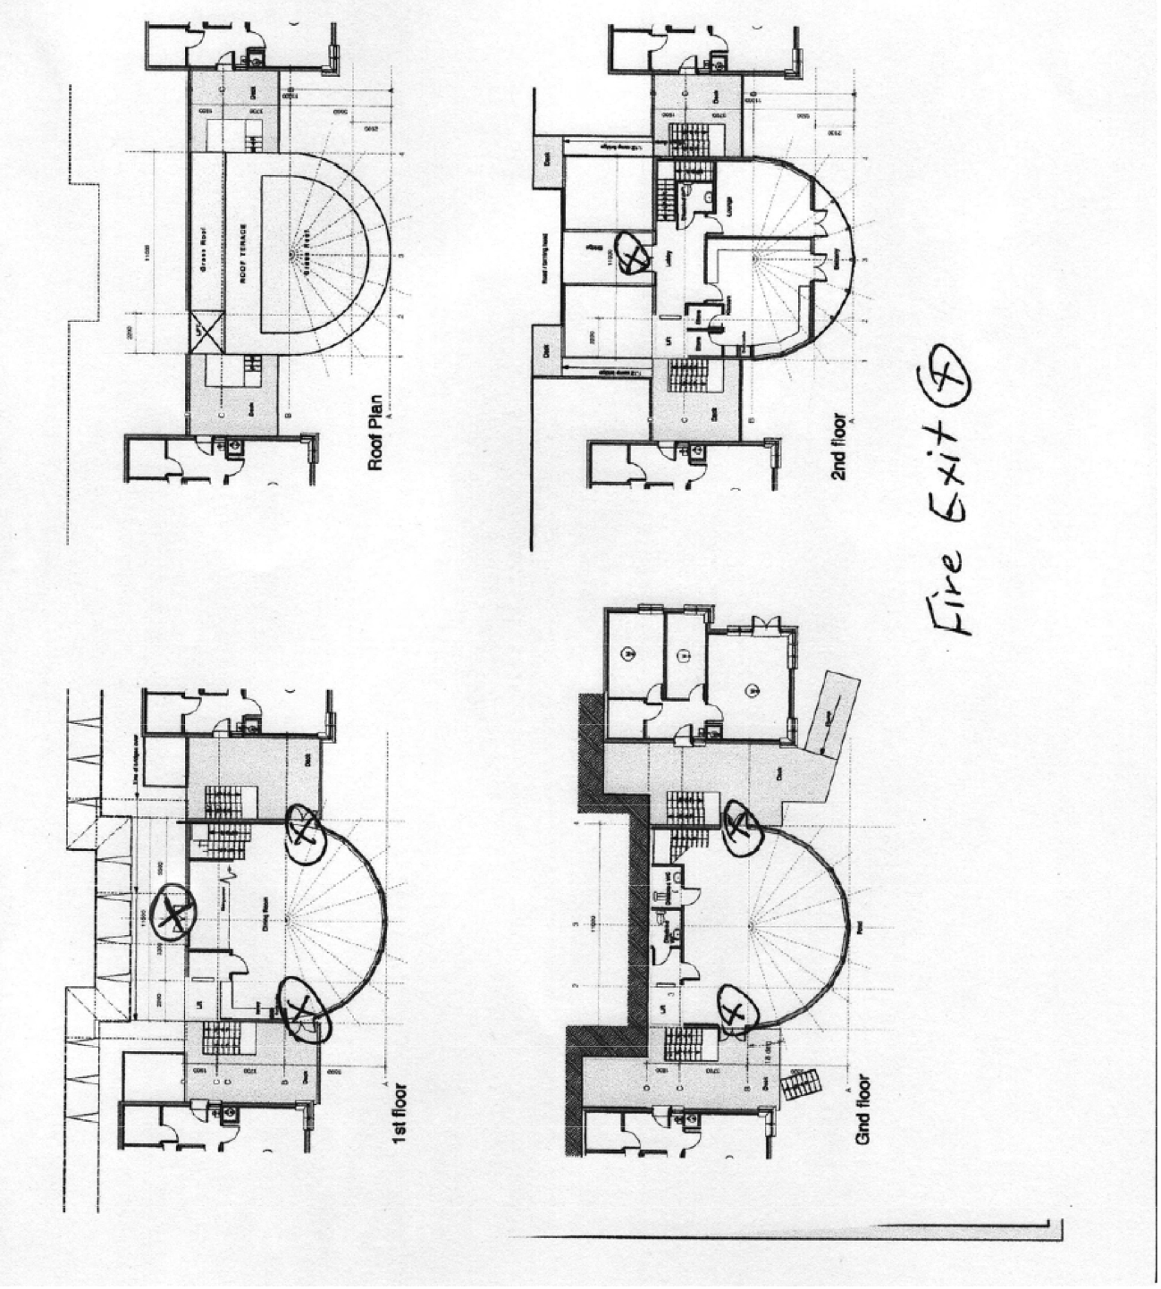
5 Identify Fire Hazards

Sources of Ignition
Electrical equipment and installations, naked flame, work processes

Kitchen, barbecues, bonfires.
Photovoltaic BP roof panels.

Sources of Fuel
Combustibles, cardboard, furnishings, wall coverings, highly flammable/dangerous substances
Cardboard boxes, furniture, paint, cooking oil in kitchen

Work Processes
Hot work, welding, soldering, chemical processes, cooking

N/A

Structural features that could promote the spread of fire
Voids and cavities in roof spaces and wall cavities

Lift shaft in common house is not protected and no double doors.
Sometimes fire doors are propped open although we have a clear and well-communicated policy not to do this. Generally this is when people are actually in the building in warm weather, rather than when the building/room is empty.
Timber clad and framed houses as described in section 3

6 Control Measures

What control measures are in to place to reduce the likelihood of a fire and to reduce the spread of fire?

E.g. reduce amount of cardboard stored in premises, separate combustible materials from ignition sources, change work processes for safer ways of working, look at installing cavity barriers and fire doors

Lids on boxes of stored paper for recycling
Cardboard to be flat packed
PV panels were all replaced with new ones during 2022.

Are any additional measures considered necessary?

Other:
will be noted from time to time.

7 Identify People at Risk
Identify and specify the location of people at significant risk in case of fire, indicating why they are at risk, and what controls are or need to be in place

Children, people with relevant learning disabilities
Older people.

Parent to be responsible and know where their children at all times.

To be aware of whereabouts and safety of people with relevant physical disabilities and relevant learning disabilities.

8 Fire fighting and Fire Detection

 | What are your current  arrangements? | Actions Required
What fire fighting equipment do you have in place and is it sufficient and located correctly? | Fire extinguishers on each floor of the C/H. Plus a fire hydrant hose for house fires. | Annual inspection by Stroud Alarms
What measures do you have in place to ensure sufficient staff are trained in use of fire fighting equipment? | Some people have experience | Training needed
What are the measures you have in place for giving warning, including the use of automatic fire detection systems? | Not very clear at present. Use of bell and shouting and break glass.  Auto-detection system in C/H | Need formal fire evacuation procedure  Nicky/ David
What signage do you have in place for the fire/detection system? | Appropriate signage | Checked annually
What measures are in place to ensure the fire routine notices are clearly displayed throughout the premises? | Stroud Alarms check | Notices to go up as above

9 Emergency Routes and Exits

 | What are your current arrangements? | Action Required
What measures are in place to ensure that everyone can safely escape from the premises? | Sufficient fire escape routes and well signed | Signs could be improved
What measures are in place to ensure that all the exit routes and exits are signed and clear of obstructions? | Checked regularly for obstructions and tripping hazards.  Part of Locking up rota.  Lease states that no belongings to be left in common areas. | Continue frequent checks  To be included in locking up duties –  Nicky/ Jane  cars parked can restrict gathering space in carpark.
What measures are in place to ensure that all exit routes are illuminated? | Bi annual checks and bi-annual safety checks. | Some bulbs need replacing.  Need new emergency lights in stairwell.
What measures are in place to ensure that all residents have been trained in evacuation procedures? | Follow Evacuation procedure below | Need to discuss at residents meeting to make all aware and have practice.

Please refer to the Department for Communities and Local Government Fire Safety Guides which can be found on the following website www.communities.gov.uk and are free to download in PDF format. Hard copies of the guides can be purchased.

10 Method for Calling the Fire Service

Name or role of the person responsible for contacting the fire service in the event of a fire or emergency

Any person who notices the fire will call 999 and alert others.

11 Actions to be taken in the event of a fire or emergency

Raising the alarm, evacuation procedures, shutdown procedures, contacting fire service etc.
Use bell, break glass in Common House and shouting.

On noticing a fire

- Try to extinguish it, only if confident and familiar with equipment
- Alert others using the bell, break glass and shouting, call 999 and ring bell
- Evacuate the building and adjacent buildings – gather in the carpark and wait for firebrigade. Or Park Gardens if safer.
- Ensure as far as possible that all occupants nearby evacuate
Other actions if confident

- Turn off gas at meters for appropriate property.
- Turn off electricity at isolator outside.
- Turn off water, if risk of flooding at street stop valve

Lift

Use Emergency Lift door opening procedure – trained people are Lee, David, Nicky

12 Training

Details of training given which should take into account the actions identified in your emergency plan. Training should be given to all residents including temporary and visitors.

Encourage people to be familiar with Emergency Procedure and immediate evacuation.

Training to be given on use of extinguishers and fire blanket - David M

More residents trained on lift emergency door opening

13 Arson Policy

What arrangements do you have in place to reduce the risk from arson?
Regular Inspections

Do you have regular waste removal; do you secure your premises when empty?

General awareness and questioning of strangers on site

Regular checking for fire hazards eg brush wood or kindling or un-boxed paper

Removal of fast ignition hazards

14 Risk Reduction Plan

What do you need to do next to make sure that you are compliant with the Regulatory Reform (Fire Safety) Order 2005 and when you will complete them?

Action Required – Copied from above sections | Priority  Low/Med/High | Actioned By | Date
Fix emergency lighting kitchen x 2 and west outside stairs | med | David/ Stroud Alarms | 2025
Alert home owners re. specific fire hazards | med | Nicky | 2025
Bells or sounder on middle floor and ground floor, new hand bell in laundry | Med | Nicky | 2025
Internal bulbs on fire exit signs | Med | David/Stroud Alarms | 2025
Send out Fire Procedure (as above) | Med | David | 2025
Training on Fire extinguishers and fire blanket | low | David | Ongoing
Training on manual lift evacuation | low | David / Lee | Ongoing
On-going checking of L2 fire detection system | low | Stroud Alarms/David | Annual and via app
Alert residents to not use stones on fire doors to prop open. | low | Malcolm
Advice and remedial work to PV panels | High | All residents with PV | Completed 2022

15 Additional Notes or Information

A number of Hazards were noted at the time of the inspection. The appropriate householder was asked to remedy. They have now been remedied. Here is a short list of some of the hazards.

Lid on paper recycling box.

Swing obstructing exit

Flower pots need
Brush wood

Bike by front door – could fall over.
A few loose articles partially blocking exit.
ladder on the stairs.
Workshop – unlocked flammables etc.
Emergency lighting noted above.
Carports containing semi-flammables.
PV panels - urgent remedial work - completed 2022

16 Smoke and heat alarm inspection in each dwelling

House/Flat | Heat? | Optical? | Ionization? | Smoke test? | Push test? | All sound?
1
2
3
4
5
6
7
8
9
10
11
12
13
14
15
16
17
18
19
House/Flat | Heat? | Optical? | Ionization? | Smoke test? | Push test? | All sound?
20
21
22
23
24
25
26
27
28
29
30
31
32
33
34
35
C/H

