www.greenheartuk.com Richard Hatfield BSc(hons). Mres - 07766 395 386
____________________________

Spring Hill Co-Housing 14th Sept 2012

Timber survey

1 Report Objective:

- Visit all 20 houses, 13 flats and the communal buildings with a member of the community to gain an understanding of any perceived problems with all aspects of timber construction, including internal, external, balconies, windows and cladding.
- Meet with householders to understand their concerns and experience of maintenance.
- Gain an understanding of any existing problems for myself.
- Report on the existing issues including suggested solutions.
- Provide maintenance guidelines for the timber work.

2 General comments
- The houses, flats and communal areas are generally in good condition, as would be expected of buildings that are only approximately 10 years old.
- The key areas of concern are the balconies and some other external timber details. Some buildings show some signs of movement, generally this is not serious, though in a couple of cases it may be. See section on this.
- As a rule, timber does not like being wet. However it will cope with getting wet as long as it dries out again reasonably quickly. If it is wet for more than a certain amount of time the typical green staining will appear (this in itself is not a problem). If its moisture content is higher still for prolonged periods rot will set in either ‘dry rot’ or ‘wet rot’ depending on the moisture content.(obviously damp and white, black, yellow or orange).
- In order to facilitate rapid drying, a number of things can help. Stopping the rain with a roof is great and maximising sun exposure also helps, (although the increase in UV from direct sunlight will also breakdown the timber!). The most important issue is getting good air flow around the timber allowing the moisture to be carried away.
- Thus always try to leave gaps between timbers and do not block air flow around decking and structures, or at least accept that if you build decking with no air flow under it or allow climbing plants to thickly cover your balcony rails that this is likely to reduce their lifespan.
- For example where decking boards are cut tight to the balcony structure there is little air flow, once this small gap is filled with dirt there is the double problem of the dirt trapping the moisture and stopping any air flow.
- So always think ‘gap’ when working with timber externally.
- The timber retaining wall structure between the houses and the car park is designed to last 50 years and should last beyond this. It is worth checking for decay every 10 years just to keep an eye on it. The gravel fill is designed to be free draining so that no moisture is trapped next to the timber.
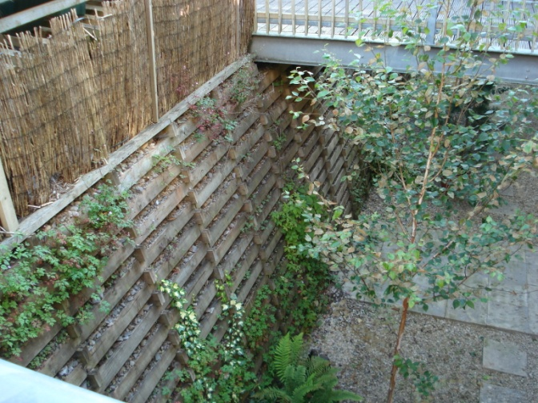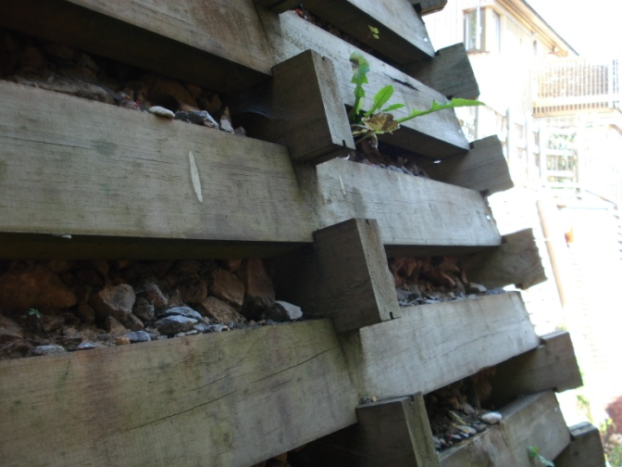

Following the first mornings survey of the communal building, the flats and the studio flats a number of generic and specific issues have been noted.

3 Common House
- Generally the common house appears in good condition and has received some regular maintenance.
- The windows and some of the external doors are not of the same quality as elsewhere on the site and need very regular painting.
- Some of the external doors are in poor condition and could do with plating on the bottom and about 200mm up the front of the door. This could be done in Stainless steel or Aluminium and made to measure. (eg Bambury sheet metal in Bristol). The thin sheet would stop moisture getting into the bottom of the door and protect the lower front edge from water and foot damage.
- The external handrails and balustrades appear to have been constructed of untreated softwood and in places are aging rapidly. This design is common to the whole site and I will cover this in a separate item.
- The view was expressed that removing some of the vertical timber bars to the stairwell where they are above hand rail height (1100mm) would improve the look of the stair from the inside and allow more light in to the stair well. This could be done fairly easily and is an aesthetic issue.

4 Flats

West Balcony and water ingress
  - The water ingress to the ground floor and first floor flats is hopefully being dealt with under the premiere guarantee scheme. This balcony has been attached to the building in a totally inappropriate way, badly compromising the waterproofing of the building. The only practical solution to properly sort the problem out is to dismantle the balconies, repair any problems to the flats and refit the balconies. The rebuilt balconies should be bolted to galvanised steel brackets that are in turn bolted to the timber frame of the house. This would allow the water proofing of the exterior of the house to be continuous, other than a few small metal brackets and allow the balconies to be structurally independent.
  - I would also advise that when rebuilding, the main structural posts and beams of the balconies are fabricated in steel or as steel-timber flitch sections. This would improve stability, longevity and minimise the problems of rot where posts meet structural beams, such as those experienced on the east side flat balconies.

East Balcony
  - Some repair work has been carried out on the East side including replacing some of the structural elements. These balconies are fixed to the house in a different way to those on the west, which is a little odd and makes me wonder if there was ever a design detail provided, or whether the builder ignored the drawings.
  - The balcony to the top flat (no20) is considerably out of level to the point where it needs to be addressed. It is unclear why and three possibilities come to mind. One, it could have been built like this, seems unlikely. Two, it dropped when the supporting posts started to rot (which have now been replaced). Three, it dropped when the structural repairs were done. Whatever the cause it needs sorting out.
  - There has clearly been an overflowing roof valley above this balcony for some time (now apparently repaired or improved) which has not improved the state of the timber or render on this balcony and would have added considerably to the general dampness on the east side.
  - The ideal solution, and the one that I would recommend, would be to rebuild the balconies in a similar manner to that prescribed for the west side. This would provide a structure that would last far longer with less maintenance and less risk of damp penetrating the skin of the flats.

General movement of the structure.
  - There appeared to be considerable movement of the structure in the top flat on the west side. The bathroom door had been modified considerably and the balcony door would no longer shut at all. A small amount of movement leading to periodic need for redecoration can be expected, but not to this degree. This could be as a result of the water ingress at lower levels affecting the structure of the building, inadequate design, or poor building practice. Either way this degree of movement suggests the building is not as structurally stable as it should be. By this I do not mean that is going to collapse, but that it will simply be impossible to maintain effectively if the degree of movement is beyond a certain level. This movement needs proper monitoring.
  - I recommend that Premiere Guarantee who are dealing with the water problems in the lower flats are informed of this issue and that it be added to the claim without delay.

- If the balconies were to be rebuilt I would suggest that the possibility of building a roof over the upper balcony should be considered, not unlike the ones on the studio flats. This would increase the lifespan of the balcony structures, keep water away from the buildings and enable the balconies to be used more often.

5 Studio Flats
- General movement of the structure was noted, with evidence of internal doors not fitting well or even closing at all (No 33). This should be monitored. Initial movement in new buildings is common, but this should stop after a year or two as the building dries out. If the building is still moving to the point where doors will not shut after 8 years this would suggest that it is structurally unsound. This could be a design fault or that it was not built properly. This does not mean it will fall down, but that it is not rigid enough to allow normal usage without irritating problems. If the building is under guarantee I would suggest making a claim.
- Balconies looking good, younger than some other parts of the site and sitting on a substantial steel cantilever structure. The timber posts although similar to those on the main flats only support one upper balcony level and are thus perfectly adequate. That said the weak point of this structure is the doubled up beams (likely to rot where they meet) and the post to beam connection which is again likely to rot at the back of the post where no air can get to it. This is not a good detail and needs to be checked regularly.

6 Houses
Like the other buildings on the site, the houses are generally in very good condition, as should be expected after 9 years. The cladding is looking good, some areas needing redecorating, but no significant signs of movement or decay. The Main areas of concern are the balconies, entrance steps and garden/entrance decking areas.
Following visits to Houses the following points were noted:
Many of the same issues appear on the houses as those already mentioned on the flats. The balcony structures are built in a variety of ways. Some use steel that is connected back to the main structure of the building providing a good rigid support. Others have steel brackets bolted to timber that is in turn fixed to the structure. This second approach is far less satisfactory and results in a less rigid structure that is more prone to decay.

Downpipes & gutters.
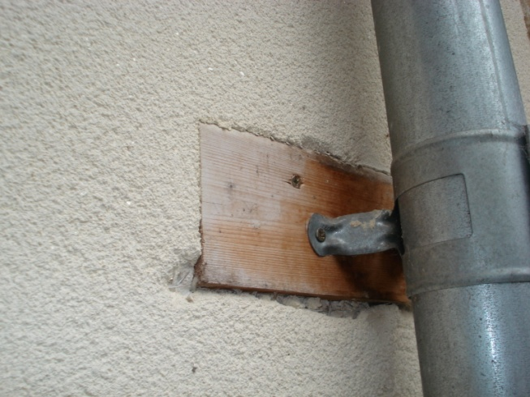
- A fairly minor point, but important to note, is that soft wood timber blocks have been fitted to the wall as a fixing point for the Lindab downpipe brackets and then simply rendered around. This is poor practice, the render should be continuous and the brackets screwed through the render into timber behind, thus allowing the render ‘rain screen’ to be continuous. This would be less likely to allow water into the building structure and would also look neater.
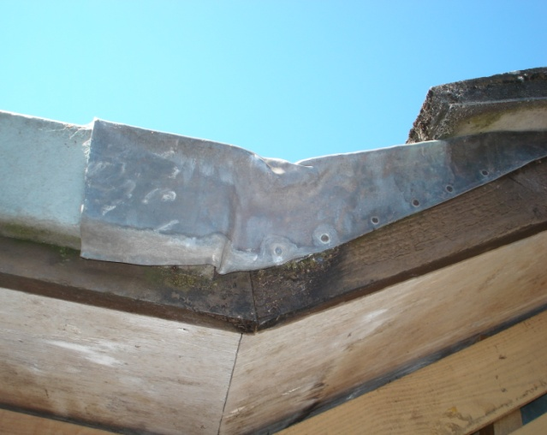
- Over flowing gutters and blocked leaking downpipes are one of the most common causes of damp in buildings, so it is worth noting and leaks when it is raining and fixing them before the water damages the building. This can be seen on the top floor of the Flats on the East side where the lead flashing on the roof has been overflowing for some time.
- Some of the downpipes, such as house no 29, have no bend or ‘shoe’ on the end of the pipe. These are a good idea in that they direct the water away from the building and can aim it more precisely in to the drain. These can be bought from the Greenshop in Bisley.

Balconies sitting on flat roofs
- Some houses, such as no 29, have single storey sections with a flat glass fibre roof and timber decking above.
- The timbers that the decking is fixed to sit on the flat roof and are vulnerable to decay.
- It is worth trying to clean out any debris that gathers on the roof below the decking. I suggest pulling up one board and washing the roof down with a hose or gently jet wash once every other year. This would also give a chance to inspect the timber for rot.

Covered balconies
- The best way to stop water decaying balcony structures and decking is to put a roof over the whole thing. This clearly would be more appropriate in some places than others.
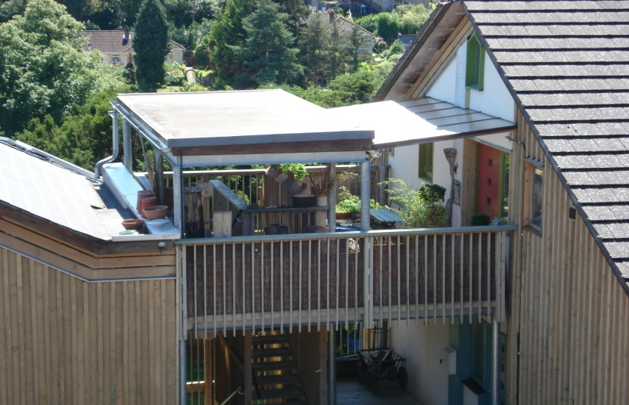
- For instance over the multi storey balconies to the flats this could help preserve the structure and minimise the problem of water dripping through one balcony on to people on the one below. The roof over the stairwell to the communal house and flats is a good example of this.

- The houses that have the shared balcony over the front door such as no 12 would benefit from a glass roof in the plane of the existing roof. This would eliminate any balcony decay problems and shelter the entrance area. There would clearly be a cost implication, but this would be a more elegant solution than the variety of solutions, both under and over the decking, that are currently in place. The danger of having the waterproofing directly under the existing balcony structure is that it will both trap moisture in the structure and restrict the air flow through the balcony structure. In addition it will focus the water running off into one area causing potential problems to the decking below.
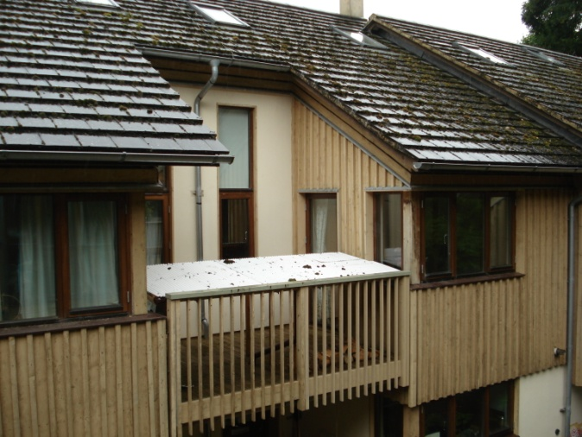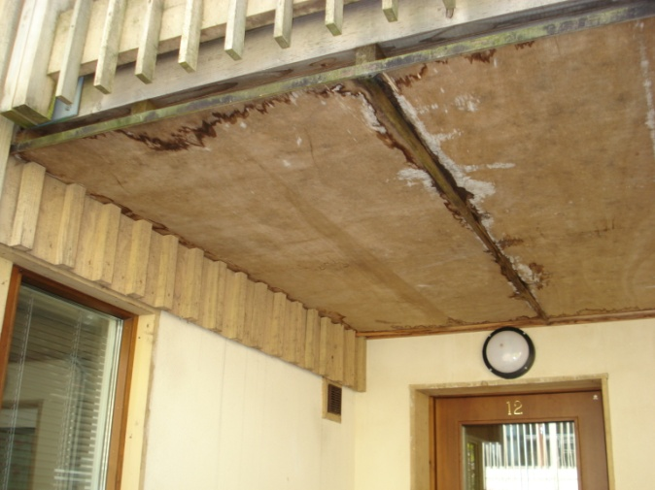

Ground level issues
- Decking at ground level needs a good air flow under it. If the sides are blocked off I would recommend one board is removed or a minimum of 25mm left between each board. The draught would ideally be a through draught from one side to another or from front to back. Clearly this is more practical in some places than others, but where there is very little air flow and no roof over the decking, the timber sub structure will have a limited life.
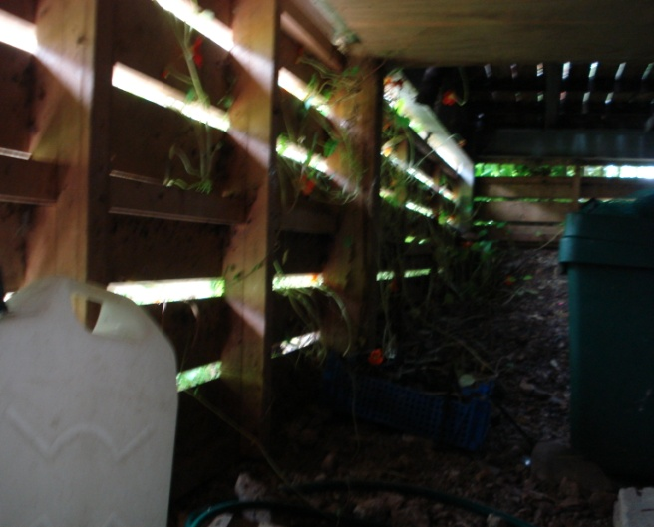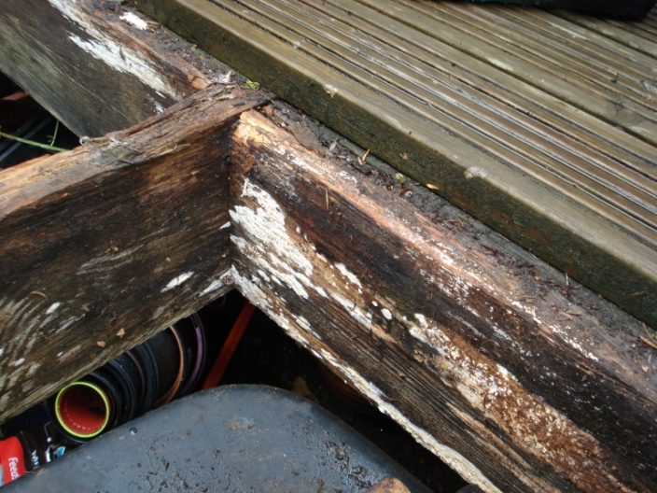
- The same applies to the space under the houses. The floors are built from concrete beam and block so there is not a problem with damp causing decay. Nonetheless, to meet building regulations this space should be ventilated with a through draught from front to back to stop excessive moisture build up.
- Where flower beds are built up against the house, where the ground level is higher than the underside of the floor, the soil should be retained with something to keep it away from the render or cladding and allow the passage of air under the house. This has been successfully done with sleepers in places and with smaller timber in others. Decking or soil up against rendered walls will trap moisture in the render causing it to decay and eventually prematurely fail allowing water into the structure of the building.
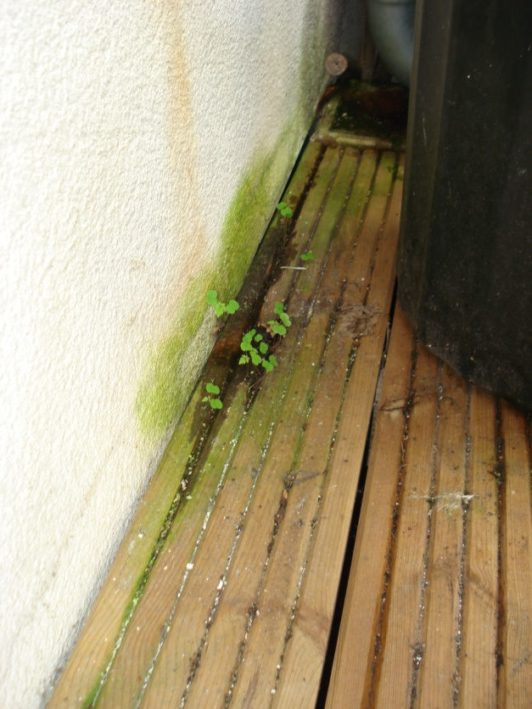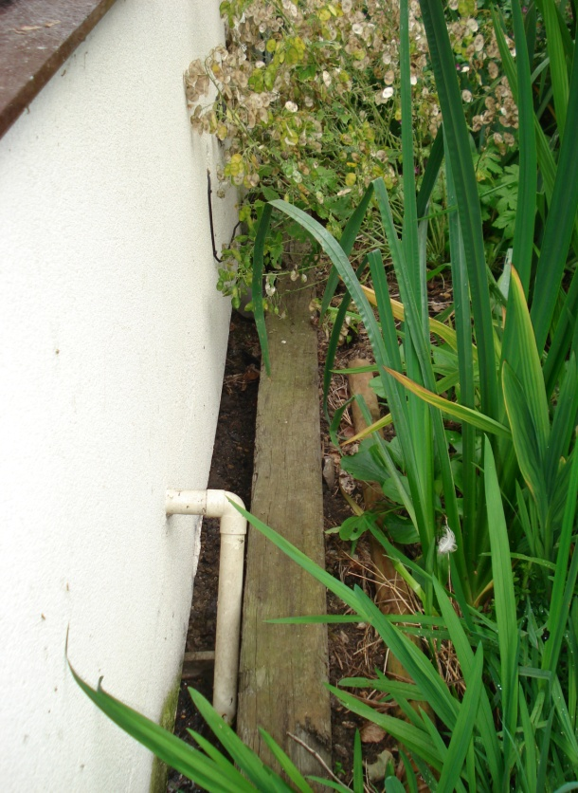
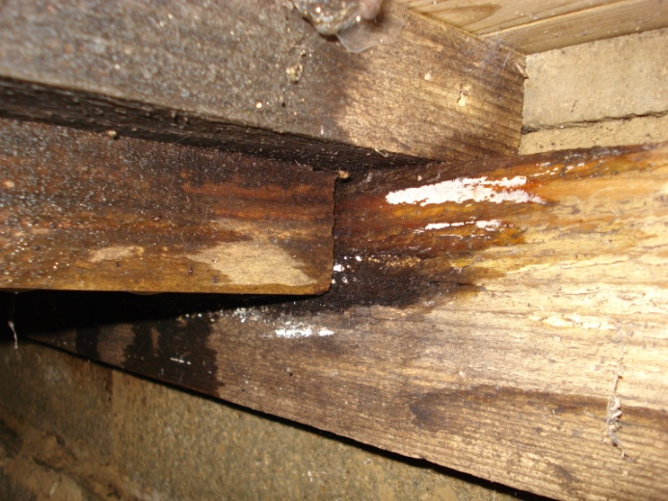
- Where decking is literally at the same level as the ground, such as the entrances to the houses in the lower terrace 1 to 12, very little air flow can be achieved. It is testament to the effectiveness of the treatment of the softwood substructure that it has lasted as well as it has. I would expect some of these areas to become soft and needing attention within the next 5 years. Some areas may be better replaced with paving. Others would last better with a roof over them to keep the water off. In other areas the drainage of the surface water should be improved so that it reaches a drainage channel before the timber. There is little else to do other than inspect these areas annually for ‘bounce’ and visual decay.
- The entrance area outside no 10 needs some better drainage. It would be worth exploring the option of cutting a hole in the tarmac and fitting a drain that discharged into the water channel that runs under the path at this point. The puddle is not doing the decking any favours in terms of longevity or slipperiness.

Steps and stairs
- Many of the stairs/steps up to the front doors are showing significant signs of decay. These have not lasted well because they were not well designed in the first place.
- Where they are in reasonable condition a strengthening batten under the front edge would improve their strength.
- Where they are failing and need to be rebuilt, there are a number of options.
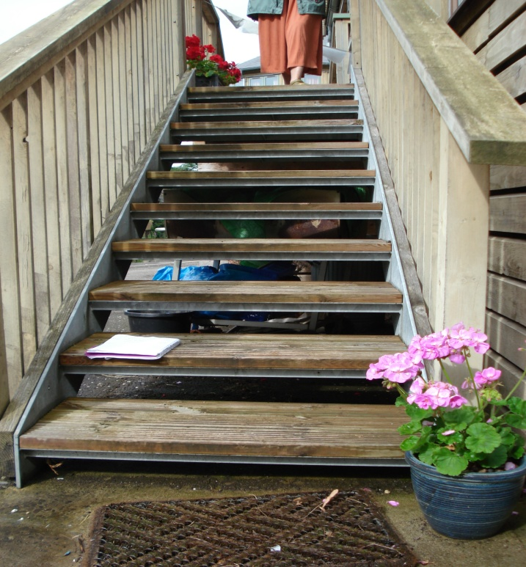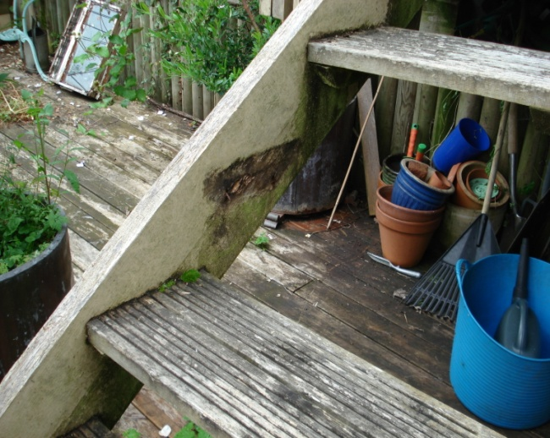
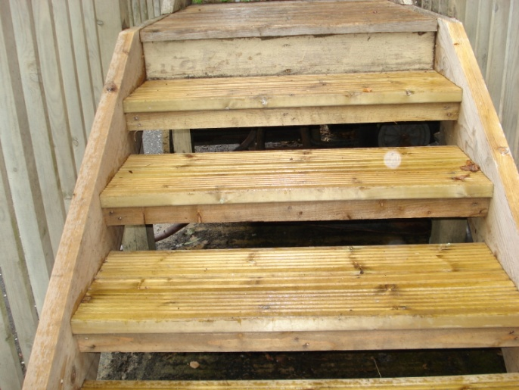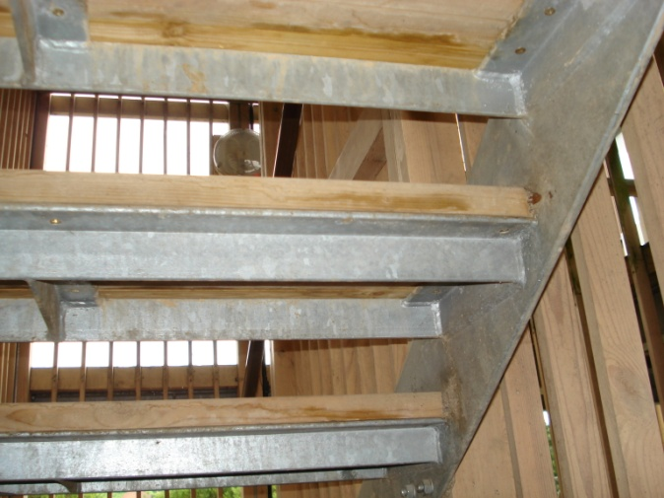
Some form of galvanised steel structure will last the longest and give that solid confidence. The strings (the sides that the treads are fixed to) should incorporate some way of fixing the balustrade/hand rail main support posts. The common house/flats stair well has full galvanised steel stair with timber treads. A cheaper option that is easier to transport and fit is to have 2 separate strings made with brackets for the treads to bolt to and then use chunky timber for the treads, preferably a durable timber in minimum 50mm thickness. Remember to leave a gap at the end of the treads so they are not hard up against the steel allowing the end grain to dry out and reduce the chance of rotting.
Alternatively a stair could be made entirely of wood in a similar style to the present ones using treated timber or hardwood and using thicker timber for the treads (minimum 50mm). I would also recommend stainless steel screws and bolts for fitting it together.

Roof issues
- Not a timber issue, but worth noting that houses numbers 5/6 has lost some mortar to the roof verge and a section of flashing has fallen out in the same area. This needs fixing asap to stop any damp penetration.
- The PV tiles on many houses are very dirty. Although the output from these tiles is small it will be considerably compromised with this level of debris and dirt covering the tiles. Annual cleaning is recommended, though this will be difficult now they are so dirty. I suggest some sort of long window cleaner’s pole that a hose can be attached to and possibly a mini tower scaffold or folding ladder on the balcony. Access needs a bit of thought.

7 Main areas for concern and suggested solutions

External structural timber
- There are a number of areas where exposed timber structure to balconies and stairs have started to fail.
- These need to be regularly inspected.
- Where significant rot has occurred after 10 years I suggest rebuilding in a different way rather than repairing what is poor original design.
- The use of galvanised steel connector plates and flitch beams is useful in removing the timber to timber joint where rot starts and also allows for individual sections of timber to be replaced if necessary.

External timber to House connections
- Where exposed timbers, such as balcony handrails, connect to the house wall, the waterproofing layer of the house should always be continuous.
- In many cases the timber has been fixed before the wall was rendered or timber clad. This breaks the ‘rain screen’ of the house and potentially allows water to penetrate behind the render and damage the structure of the house.
- The timber should be cut back and the render or cladding reinstated. If the timber has insufficient support and needs to be re-fixed to the wall, this should be done with a metal bracket(galvanised steel or Stainless) and stainless steel screws going through the render into timber beyond.
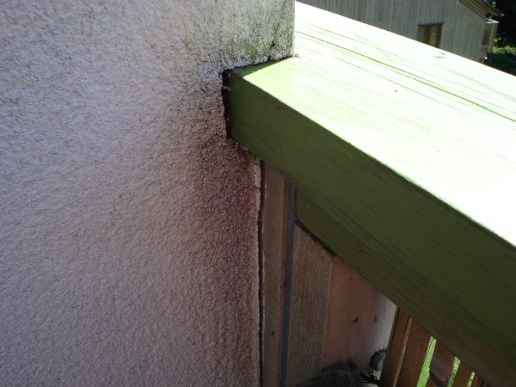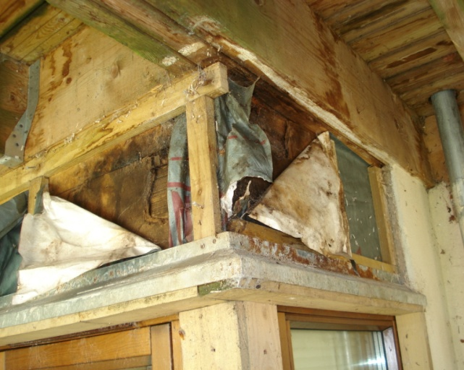

Balcony Hand rails
- Flat timber hand rails exposed to the weather will always cause problems, great for resting your cuppa on but also good at collecting water.
- Where they are soft with rot or crumbling they should Ideally be replaced with a durable timber, preferably hardwood and be planed to a slope of at least 5 degrees with a drip groove on the under sides. They would then either be left to silver or decorated every other year.
- Their life span will clearly depend on the location, amount of UV, rain and maintenance they have received and also on the quality of the piece of wood that was used.
- They could be planed to an angle in-situ, although this would be tricky where they meet the building, it would generally improve the water run-off and increase lifespan.
- Some have been left and are in reasonable condition, others have been regularly maintained and are starting to rot, others have had all the soft material cut away and then been sanded smooth for an organic look. Some have already been replaced. It all comes down to personal preference as long as they are not structurally unsound.
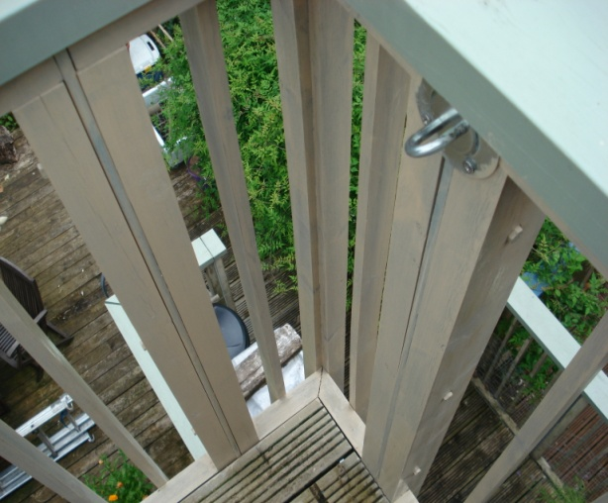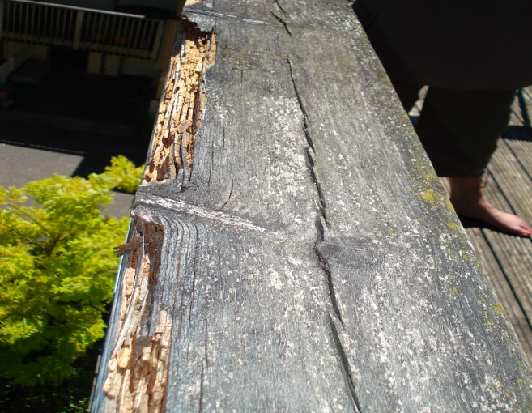

Balcony balusters
The timber spindles that run from the hand rail down to the deck of your balconies are fixed to a horizontal timber at the bottom. In places this horizontal timber is not well fixed and the single screws that attach the spindles to the horizontal pieces are vulnerable to rusting through. It is worth checking all these annually to ensure they are strong enough to stop a child falling through.
Where the whole hand rail, spindle structure is in poor condition it could be replaced with an alternative. This could be a prefabricated railing of some sort in steel (galvanised or Powder coated) or a hardwood top and bottom rail with Stainless steel rods between.(see picture below). The building regulations rules state that the hand rail should be 1100mm high with no hole large enough to allow a 100mm sphere to pass through.
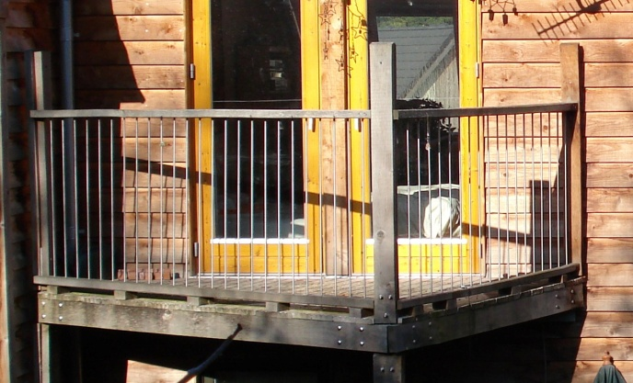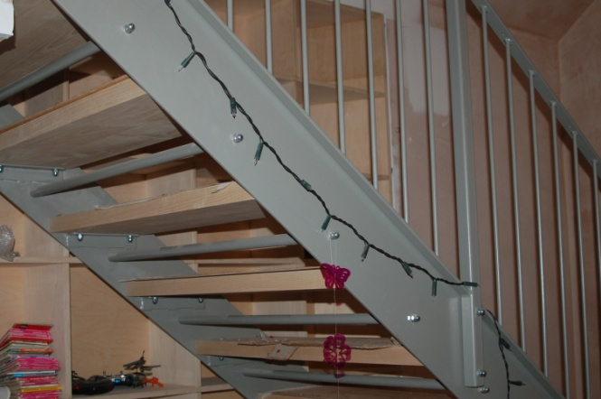
Oak and stainless steel – no decoration Powder coated steel with hardwood treads

Plywood soffits
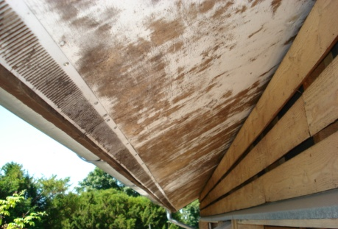
The ply soffits that are common to most of the houses look rough because the paint finish on them has allowed moisture to get to the plywood and stained the surface. The ply is not damaged so sanding and repainting with appropriate paint (Baileys recommendation) should improve the appearance enormously.

Plant pots and other containers on Balconies.
As a general rule we can go back to the concept that wood likes to dry out. If a pot is sitting directly on the decking when it is watered the water drains out of the pot directly onto the decking. Thus if the pot is kept damp, so is the decking. A pot on feet allows more air flow and thus the wood will dry which helps. A pot on a tray or saucer that does not over flow stops the water getting to the decking in the first place. The ideal solution is a pot on a tray on legs, no water on decking, good air flow, and no water on your neighbours heads!
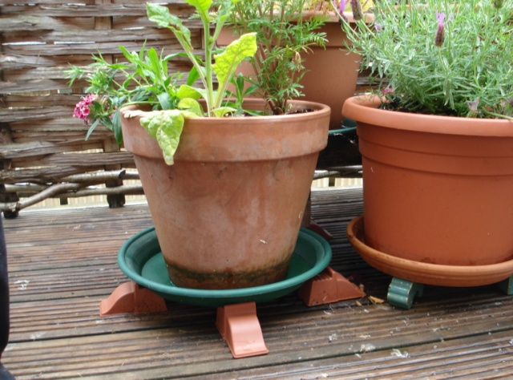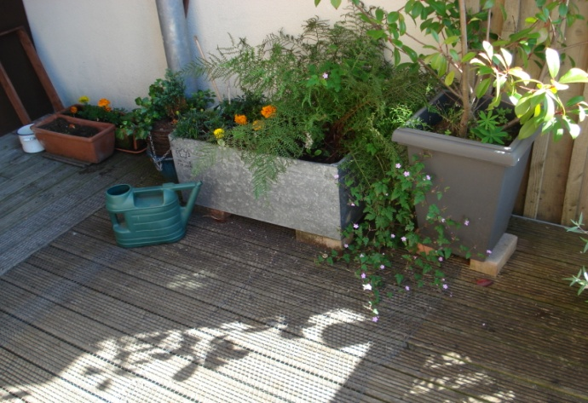
Raised & with trays to catch water – good! Raised for air flow – good! No trays – bad!

8 Maintenance schedule:

Task | How Often | Reason
Move plant pots | Annually | Allow decking to be cleaned and to dry.
Clean decking jet wash or water and stiff broom/brush | Annually | Remove debris that traps moisture. Remove debris between boards that limits drying air flow. Remove algae that makes boards slippery.
Clean out gutters | Annually | Reduces drain blockage and gutter overflow that can lead to damp walls.
General visual check for rot | Annually | Be aware of up coming issues and find a problem before it becomes dangerous eg hand rails becoming loose or stairs breaking.
PV tiles cleaning | Annually | Improve performance, tricky access. Long pole and a tower scaffold.?
Level threshold entrance decking inspect | Annually | With very little ability to dry out this is very vulnerable to decay and collapse.
Decorate Hand rail/any flat external timber | Biennially | Prolong life of timber and improve aesthetic. Rain, frost and UV from all that sun will damage flat surfaces very quickly.
Treat decking with oil | Biennially | Reduces growth of slippery algae etc
Clean under decking where sitting above glass fibre roof | Biennially | Debris trapped on the roof will stop the sub structure drying out and accelerate decay. These timbers are very vulnerable to decay.
Check external steps and stairs for rot/weakness | Biennially | Clearly a potential hazard if they fail. Any very bouncy stair should be improved/repaired/replaced.
Check there are no areas where soil or decking is up against render or timber clad walls. | Biennially | Green render, black cladding or simply no gap between the ground and the wall is a sign this needs to be addressed. Imagine that air flowing around your house keeping it healthy!
Paint exposed timbers | 5 years | Outside timbers that get a lot of sun and rain will need redecorating after 5 years if you want to keep them in top condition.
Decorate windows and doors | 10 years | Most external timbers such as windows and doors, fascias and soffits will need redecorating about every 10 years.
Replace timbers where decay is advanced or aesthetically unacceptable | 10 years | The time to replace comes down to what you are happy to live with in terms of the look of the timber, but clearly a hand rail needs to be safe and secure at the very least.
Inspect timber retaining wall to car park | 10 years | 50 yr design life, but worth checking areas that are hidden by planting and have less air getting to them.

The above table is a guide to best practice, however different householders will have differing ideas as to the acceptable aesthetic state of their timber work. This comes down to personal preference, assuming the structure is still sound enough to be safe.
Durable timbers ( see TRADA timber classification), softwoods such as larch or western Red Cedar, native hardwoods such as Sweet Chestnut, Oak and many tropical hardwoods such as Mahogany and Iroko will last for many years outside without decoration. Regular painting or staining will lengthen their life a little, but it is more about appearance. If you prefer the painted or stained look then it must be done regularly to keep it looking good.

Useful contacts:

Fixings, screws, bolts etc. Fast Fix Gloucester 01452 – 527 885
Steel fabrication from brackets to stairs, Gloucester Street Forge, Slad Rd. Ben on 01453 – 766 542
The Greenshop, Bisley. 01452 – 770 629
Bailey Paints. 01453 – 882 237
TRADA web site for timber advise – try www.trada.co.uk/techinfo/tsg
Bambury sheet metal workers. (Bristol) Tim on 0117 – 971 9216

